**Techplement Internship**

**Week-1 Task :** Deploying WordPress Application in Monolithic and Microservices Architectures.

Description: 1 EC2 instance, deploy word press and MYSQL on the same instance. Configure the necessary security group for the instances.

EC2 instance type: t2-micro, AMI: ubuntu-*.

Create a welcome page in word press that will be the homepage.

**Introduction**: I have deployed a WordPress application using Apache in monolithic architecture.

**Step-1:** I have launched an ec2 instance and connected to it using the command**.**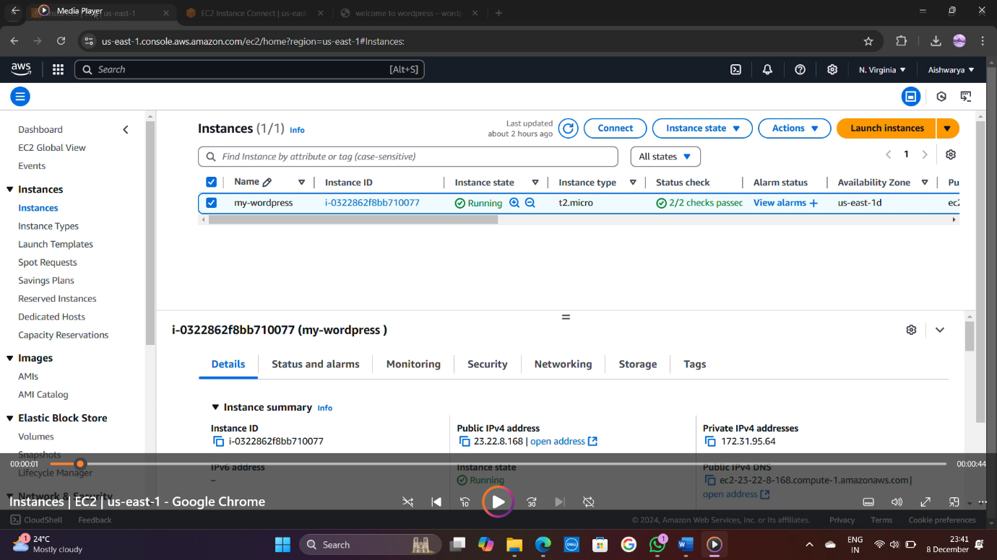  # Installing apache server on Ubuntu

sudo apt install apache2

# Installing php runtime and php mysql connector

sudo apt install php libapache2-mod-php php-mysql

# Install MySQL server

sudo apt install mysql-server

**Step-2**: Login to MySQL server

sudo mysql -u root

# Change authentication plugin to mysql_native_password (Choose strong password)

ALTER USER 'root'@localhost IDENTIFIED WITH mysql_native_password BY 'aishwarya880';

# Createting a new database user for wordpress

CREATE USER 'aishwarya'@localhost IDENTIFIED BY 'aishwarya880';

Step-3: Create a database for wordpress

Creating database wordpress;

# Grant all privileges on the database 'wordpress' to the newly created user

GRANT ALL PRIVILEGES ON wordpress.* TO 'aishwarya'@localhost;

FLUSH PRIVILEGES;

EXIT

**Step-4:** Downloading wordpress

cd /tmp wgethttps://wordpress.org/latest.tar.gz;

#Unzip the file

tar -xvf latest.tar.gz;

#Moving Wordpress folder to apache document root

sudo mv wordpress/ /var/www/html;

**Step- 5: Configuring the Application (WordPress Example)**

sudo nano /var/www/html/wp-config.php

Step-6: Update the database settings:

define('DB_NAME', 'app_db');

define('DB_USER', 'app_user');

define('DB_PASSWORD', 'yourpassword');

define('DB_HOST', 'localhost'); // Since MySQL is on the same instance

Step-7: Command to restart apache server

sudo systemctl restart apache2;

**Step-8: Testing the Application**

1. Open your browser and go to the public IP of your EC2 instance:

http://<your-ec2-public-ip-address>

1. The application setup page should load, and you can proceed with configuring the application (e.g., WordPress setup page).

Step-9: Accessing the Application

Finally, I accessed /wordpress to complete the WordPress setup wizard

